Rayat Shikshan Sanstha’s

**Chandrabai-Shantappa Shendure College, Hupari**

**Activity Report**

**Name of the Activity :** Bank Visit under MoU

**Department** : Department of Economics

**Date** : 23rd November, 2022

**Venue** : Paisafund Cooperative Bank, Hupari, Tal Hatkanangle,

Dist. – Kolhapur

**Aims/Objectives** : 1. To understand working and management of

cooperative banking.

2. To know functions of cooperative banks.

**Nature of the Activity:**

The Department of Economics organized study visit to Paisafund Cooperative Bank, Hupari, Tal. Hatkanangale, Dist. –Kolhapur under MoU on 23rd November, 2022. 35 students of have been participated to this study visit. Students have been acquainted functions of cooperative banking and they understood the working and management of cooperative bank. The activity has been conducted by Dr. Barale S. I. and Prof. Kashid K.A.

**Outcomes:**

1. Students understood practical working and functions of cooperative banking.
2. Students acquainted cooperative Principles especially in banking sector.

**Support of teaching and non-teaching Staff**

1. Dr. Barale S.I.
2. Prof. Kashid K.A.

Head, Dept. of Economics Principal

Rayat Shikshan Sanstha’s

**Chandrabai-Shantappa Shendure College, Hupari**

**Dept. of Economics**

**Study Visit to Paisafund Bank, Hupari under MoU Activiy on 23 Nov. 2022**

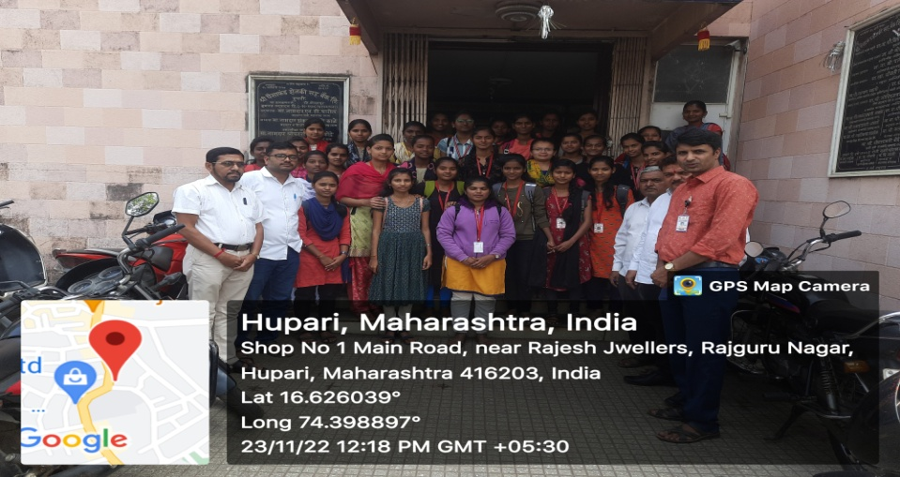

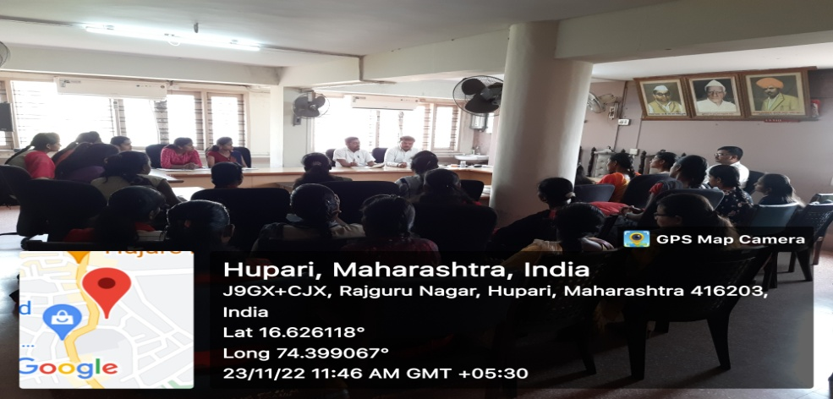

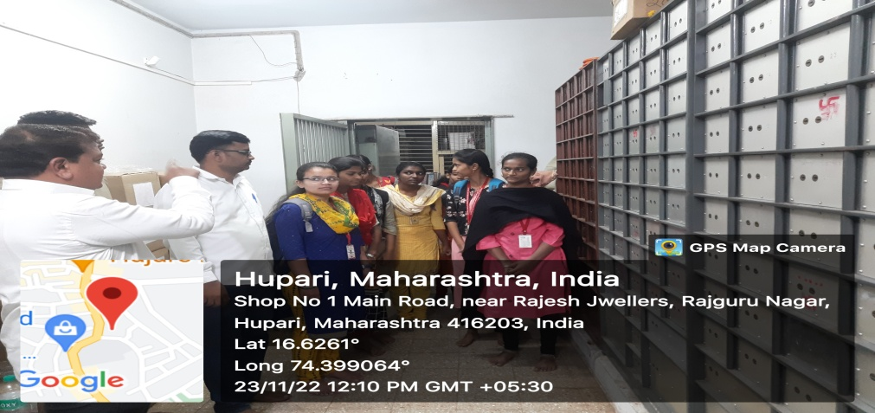

Head, Dept. of Economics Principal