Rayat Shikshan Sanstha’s

**Chandrabai-Shantappa Shendure College, Hupari**

**Activity Report**

**Name of the Activity :** Lead College Workshop on “Agricultural Prices”

**Department** : Department of Economics

**Date** : 18th March, 2023

**Venue** : Chandrabai-Shantappa Shendure College, Hupari

**Aims/Objectives** : 1. To understand about how agricultural prices are determined.

2. To know ‘Fair Remuneration Prices’ of agricultural products especially

sugarcane are determined.

**Nature of the Activity:**

The Department of Economics organized Lead College Workshop on “Agricultural Prices” on 18th March, 2023. To understand about how to determine agricultural prices and the role of government, the dept. of Economics organized workshop. Dr. S. M. Bhosale, Head and Professor, S P College, Satara and Dr. D. B. Shedage, Professor, S K. College, Deur has guided to the students about the agricultural prices and how to determine ‘Fair Remuneration Prices’. More than 100 students were participated to this workshop.

**Outcomes:**

1. Students understood that how to determine agriculture prices.
2. Students acquainted with ‘Fair Remuneration Prices’.

**Support of teaching and non-teaching Staff**

1. Dr. Barale S.I.- Co-coordinator, Lead College Workshop
2. Smt. Shinde T.S.- Asst. Professor

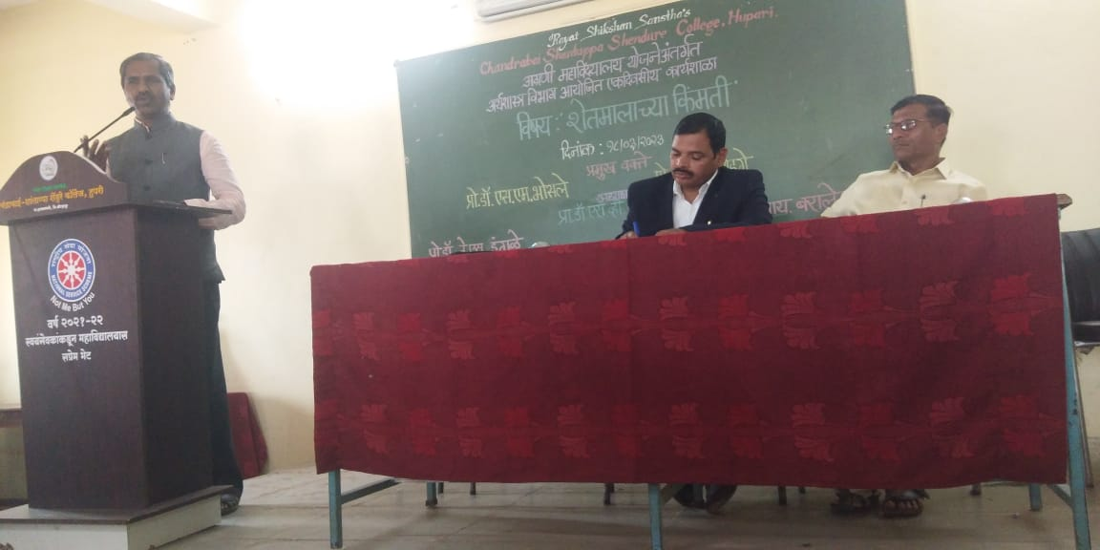 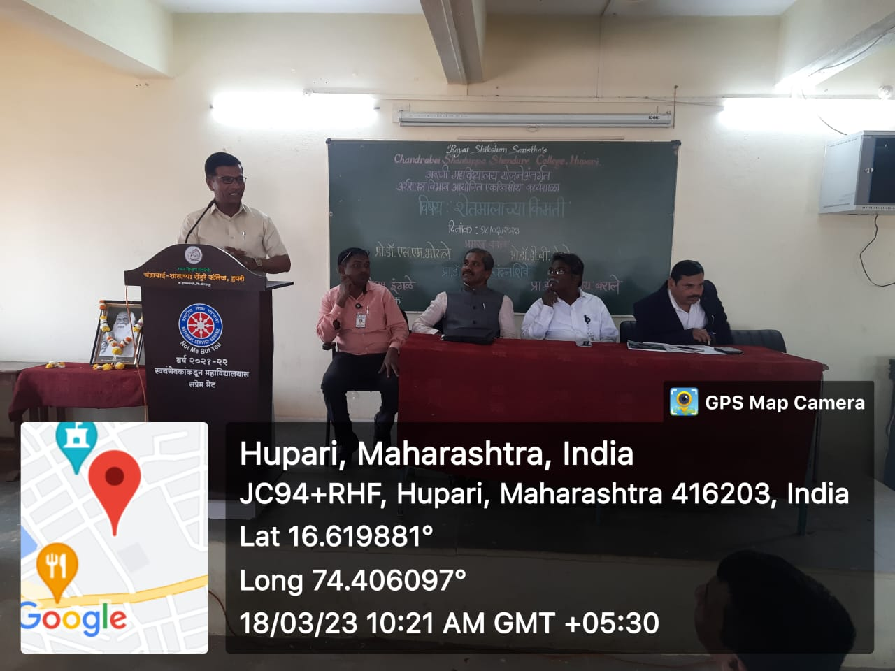

अग्रणी महावियालय योजनेअंतर्गत अर्थशास्त्र विभागाच्या वतीने आयोजित

एकदिवशीय कार्यशालेत मार्गदर्शन करताना प्रो.डॉ. एस. एम. भोसले आणि प्रा.डी.बी. शेडगे

Head, Dept. of Economics Principal