Rayat Shikshan Sanstha’s

**Chandrabai-Shantappa Shendure College, Hupari**

**Activity Report**

**Name of the Activity :** Two-day National Level Web-Seminar on “Dynamics of Research Methodology

in Humanities and Commerce”

**Department** : Department of Economics

**Date** : 29th & 30th April, 2024

**Venue** : Chandrabai-Shantappa Shendure College, Hupari

**Aims/Objectives** : 1. To understand the dynamics of research methodology in Humanities

2. To know the dynamics of research methodology in Commerce

**Nature of the Activity:**

The Department of Social Sciences especially economics of the college organized Two-day National Level Web-Seminar on “Agricultural Prices” on 29th & 30th April, 2024. To understand Dynamics of research methodology in Humanities and Commerce, the dept. of Social Sciences especially organized National Level Web-Seminar. Prof. Dr. M.S. Deshmukh, Dean, Faculty of Humanities, Shivaji University Kolhapur inaugurated the seminar and delivered Key Note Address. Dr. Pankaj Singh, Dept. of History, Dr. Harisingh Gaur University (Central University), Sagar (M.P.), Dr. Sardar Patil, A S C College Devrukh, Dr. N.G. Prakasha, Govt. First Aid College, Nagmangal (Karnataka) and Dr. Anil Yedage, P C College, Goa have guided about the theme as Speaker. More than 70 participant were attended the seminar.

**Outcomes:**

1. Acquainted with Dynamics of Research Methodology in Humanities.
2. It helps to draft research articles, minor & major projects, thesis etc.

**Support of teaching and non-teaching Staff**

1) Mr. Mulani K. I. –Coordinator 2) Dr. Sontakke M L- Coordinator

1. Dr. Barale S.I.- Organizing Secretary 4) Mr. Bhandare S. A. – Member 5) Smt. Shinde T. S.- Member

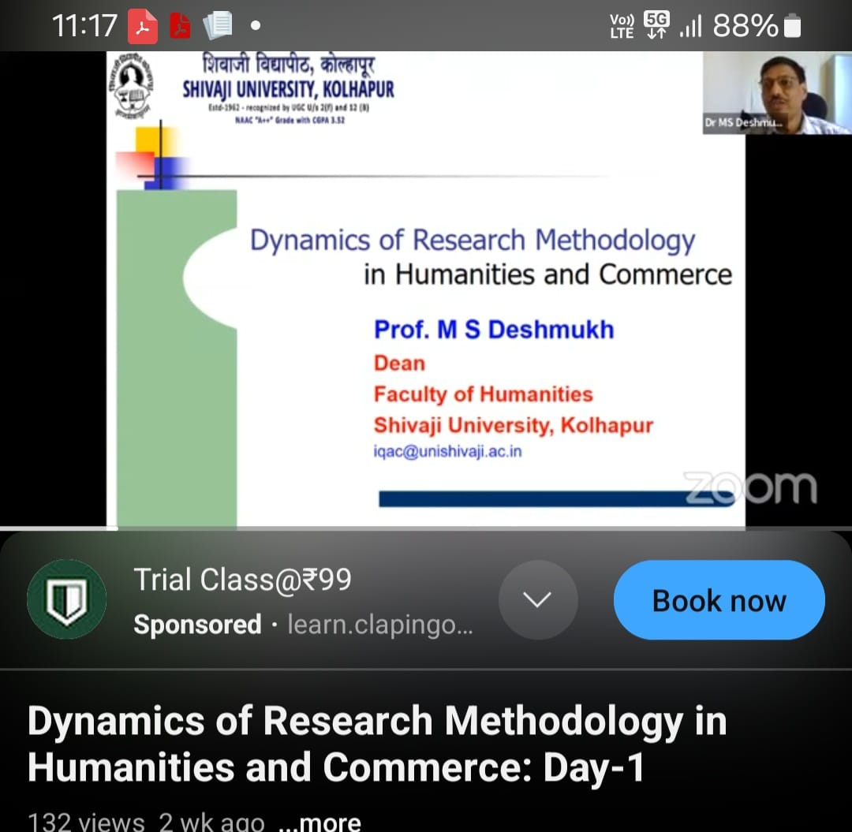 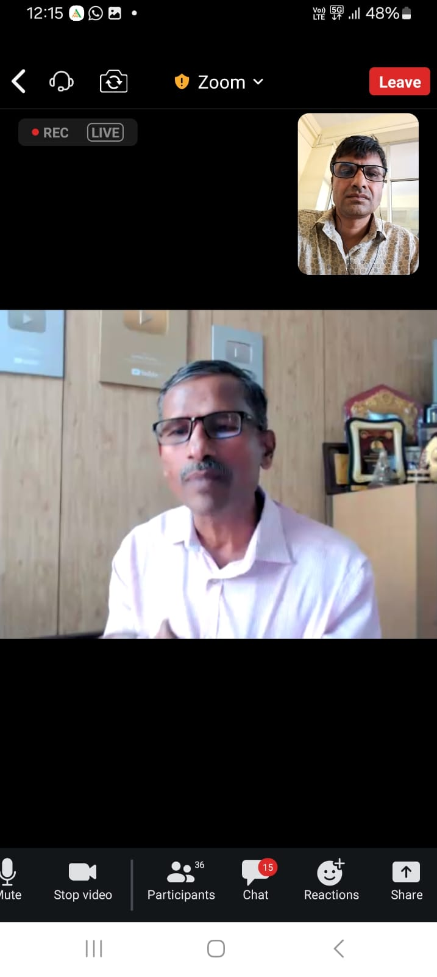

Prof. Dr. M.S. Deshmukh, delivered Key Note Address

Dr. N.G. Prakasha, delivered guided as Speaker

Head, Dept. of Economics Principal