Rayat Shikshan Sanstha’s

**Chandrabai-Shantappa Shendure College, Hupari**

**Activity Report**

**Name of the Activity :** Industrial Visit

**Department** : Department of Economics

**Date** : 24th November, 2022

**Venue** : Shri. Hanuman Cooperative Dairy Institution, Yalgud

(Dist. Kolhapur)

**Aims/Objectives** : 1. To understand working and management of

Cooperative dairy institution

2. To know functions of cooperative dairy institution.

**Nature of the Activity:**

The Department of Economics organized study visit to Shri. Hanuman Cooperative Dairy Institution, Yelgud, Tal. Hatkanangale, Dist. –Kolhapur on 24th November, 2022. To understand working and management of the cooperative dairy institution and to know the functions of the dairy institutions, dept. of Economics organized the study visit. 22 students of have been participated to this study visit. The activity has been conducted by Smt. Shinde and Dr. Barale S. I.

**Outcomes:**

1. Students understood practical working and functions of cooperative banking.
2. Students acquainted cooperative Principles especially in banking sector.

**Support of teaching and non-teaching Staff**

1. Smt. Shinde T.S.
2. Dr. Barale S.I.

Head, Dept. of Economics Principal

Rayat Shikshan Sanstha’s

**Chandrabai-Shantappa Shendure College, Hupari**

Dept. of Economics

**Study Visit to Shri. Hanuman Cooperative Dairy Institution, Yalgud on 24th Nov. 2022**

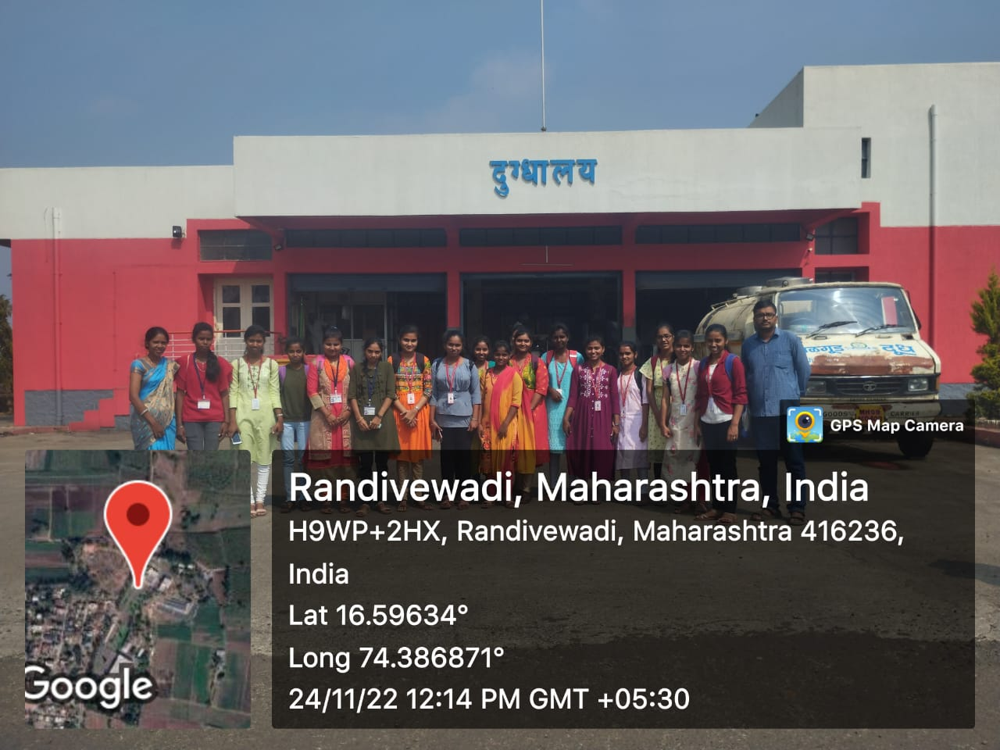

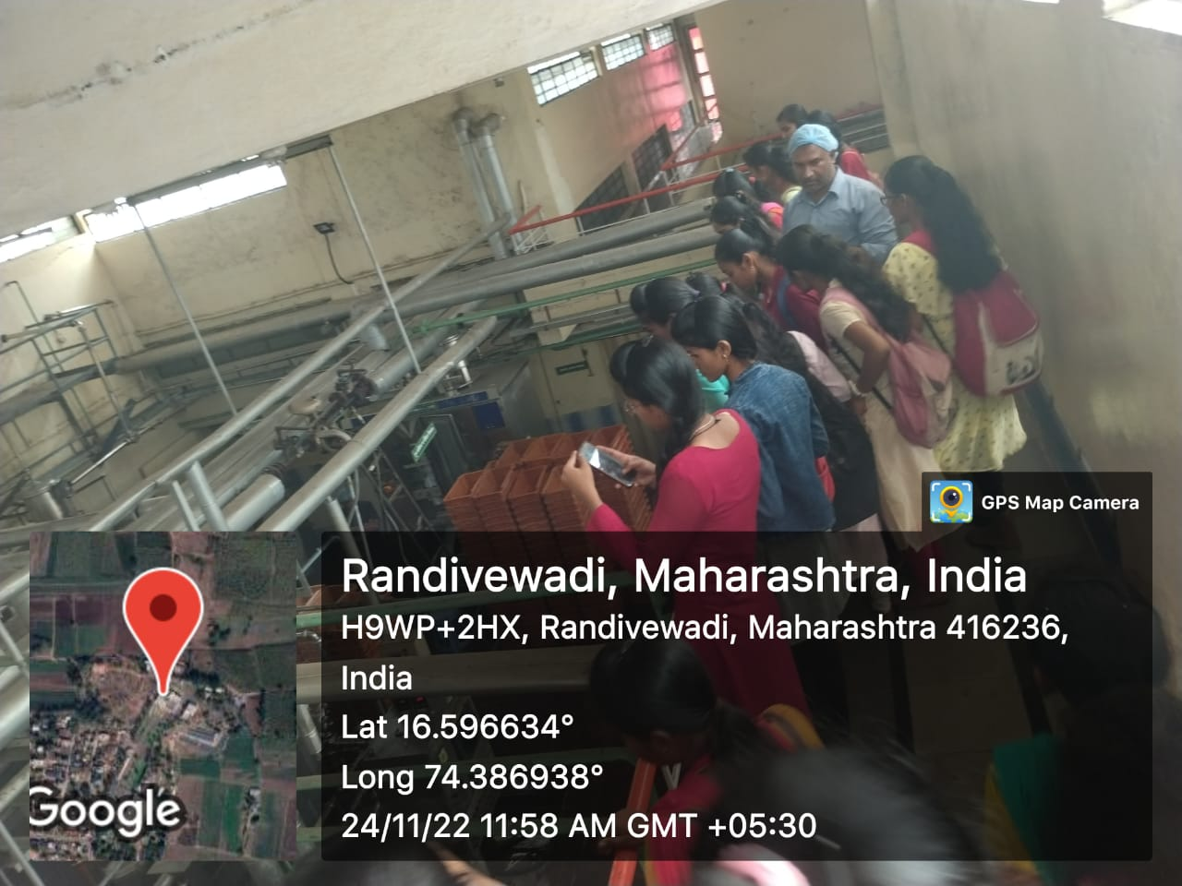

Head, Dept. of Economics Principal