Rayat Shikshan Sanstha’s

**Chandrabai-Shantappa Shendure College, Hupari**

**Activity Report**

**Name of the Activity :** Live Budget 2023

**Department** : Department of Economics

**Date** : 1st February, 2023

**Venue** : Chandrabai-Shantappa Shendure College, Hupari

**Aims/Objectives** : 1. To understand budget process of Govt. of India.

2. To get the information of income and expenditure of an economic year

of the Government.

.

**Nature of the Activity:**

The Department of Economics organized Live Budget Session for the year 2023 on 1st February, 2023. To understand budget process of the government and availed the information of income and expenditure of the govt. 30 students of have been active participated to this programme. The activity has been conducted by Dr. Barale S. I. , Mr. Bhandare S.A., Ms. Shinde T.S.

**Outcomes:**

1. Students understood budgetary process of the Government.
2. Students got experiential knowledge of allocation and collection of resources of the budget.

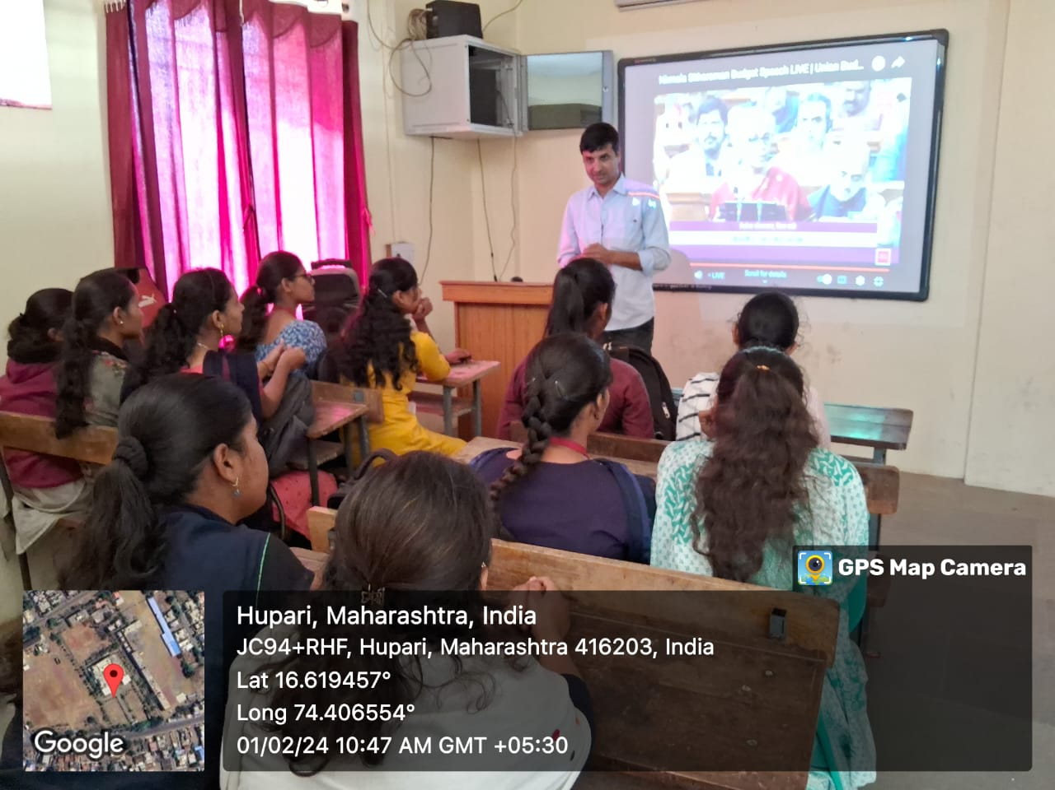 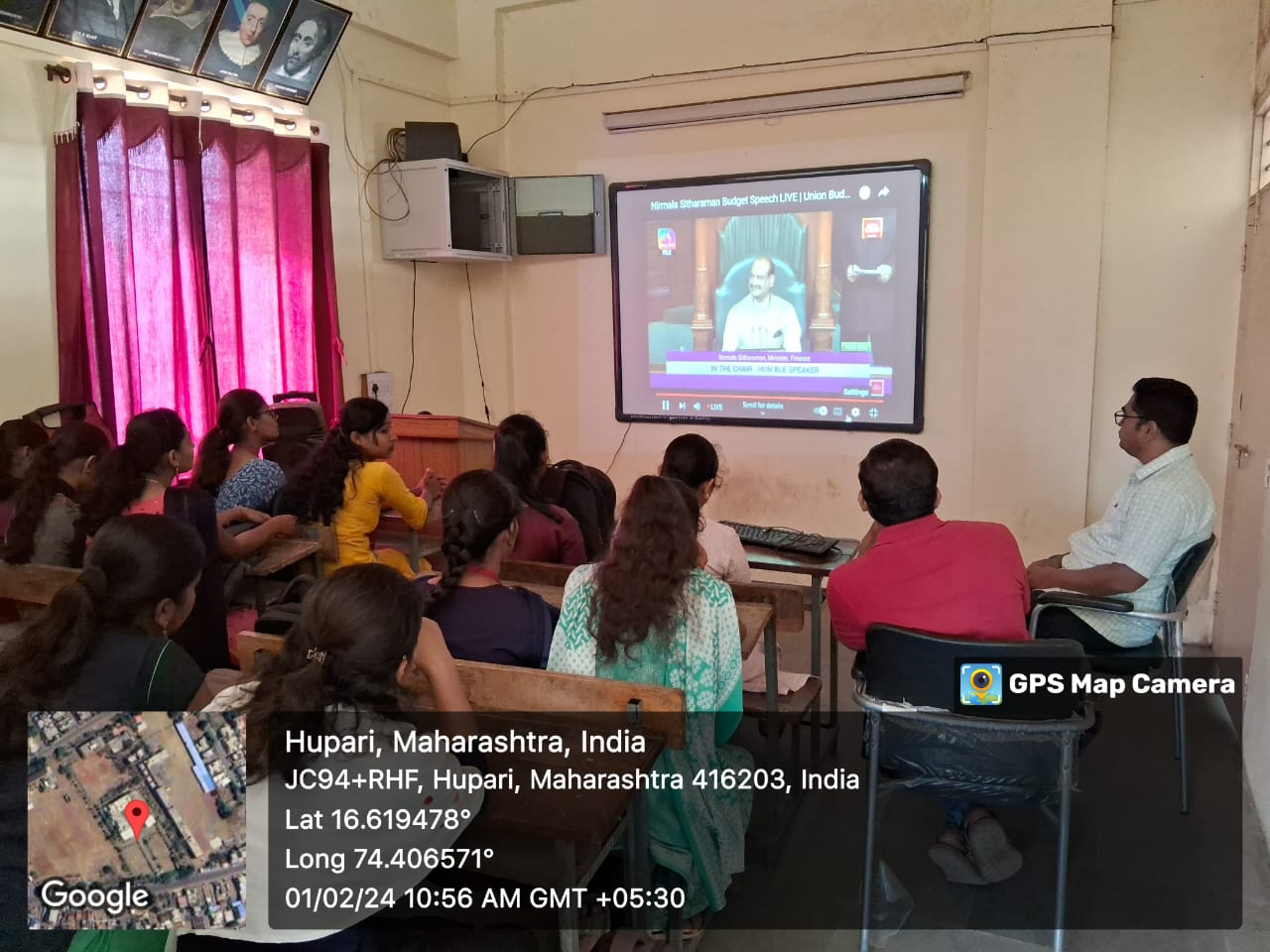

Dept. of Economics organized Live Budget Session for the year 2024 on 1st February, 2024.

Head, Dept. of Economics Principal