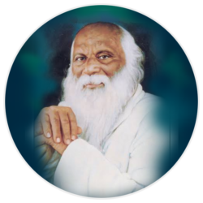**Rayat Shikshan Sansthas’**

**CHANDRABAI-SHANTAPPA SHENDURE COLLEGE, HUPARI**

**Activity Report**

**Name of the Activity :** Wallpaper Presentation on “Population of India”

**Department** : Department of Economics

**Date** : 13th August, 2024

**Venue** : Chandrabai-Shantappa Shendure College, Hupari

**Aims/Objectives** : 1. To provide guidance and platform to the students with a

aptitude for creative thinking on Population

2. To give wide publicity of publication of students

articles and creative arts in the wallpaper.

**Nature of the Activity:**

The Department of Economics organized Wallpaper Presentation on “Population of India” on 13th August, 2025. For providing platform and wide publicity of students’ creative thinking, Dept. of Economics organized wallpaper on above mentioned theme. This programme inaugurated by the auspicious hands of Prin. Dr. Anand Menase (Belgum, Karnataka) and Prof. Dr. Arjun Chavan Ex. Head, Dept. of Hindi, Shivaji University, Kolhapur. 10 students have participated in the activity.The activity has been conducted by Dr. S. I. Barale, Mr. S. A. Bhandare and Smt. T. S. Shinde.

**Outcomes:**

1. Students have got ideas and platform of wallpaper presentation.
2. Creative Presentation of Students have got wide publicity through the activity.

**Beneficiaries:**

There were 10 Students of the Department have been participated

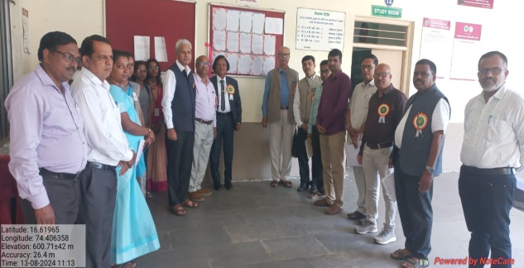 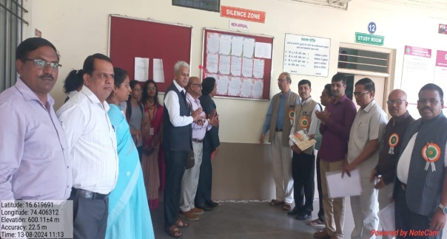

The wallpaper inaugurated by Prin. Dr. Anand Menase and Prof. Dr. Arjun Chavan