Rayat Shikshan Sanstha’s

**Chandrabai-Shantappa Shendure College, Hupari**

**Activity Report**

**Name of the Activity :** Industrial Visit

**Department** : Department of Economics

**Date** : 9th January, 2024

**Venue** : Jijamata Mahila Audyogik Sahakari Sangh Mangur

Tal-Chikkodi, Dist- Belgum (Karnataka)

**Aims/Objectives** : 1. To understand functions and management of Cooperative Institution.

2. To get the experiential knowledge of working of cooperative Jijamata

Mahila Audyogik Sahakari Sangh Mangur.

**Nature of the Activity:**

The Department of Economics organized study visit to Jijamata Mahila Audyogik Sahakari Sangh Mangur Mangur, Tal-Chikkodi, Dist- Belgum (Karnataka) on 9th January, 2024. To understand working and management of the cooperative and to know the functions of the cooperative bakery production institution, dept. of Economics organized the industrial visit. 30 students of have been participated to this study visit. The activity has been conducted by Dr. Barale S. I. , Mr. Bhandare S.A., Ms. Shinde T.S., Mr. Kashid K.A.

**Outcomes:**

1. Students understood working and functions of cooperative banking.
2. Students acquainted cooperative Principles especially in bakery production institution.

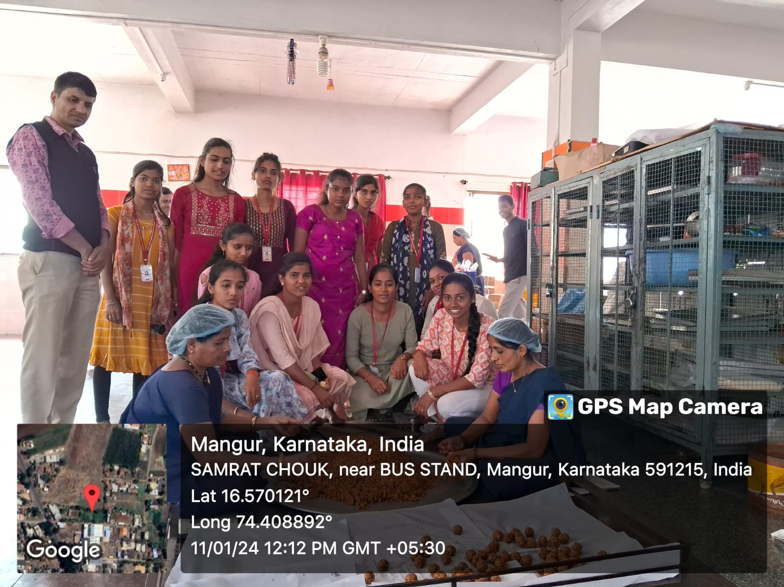 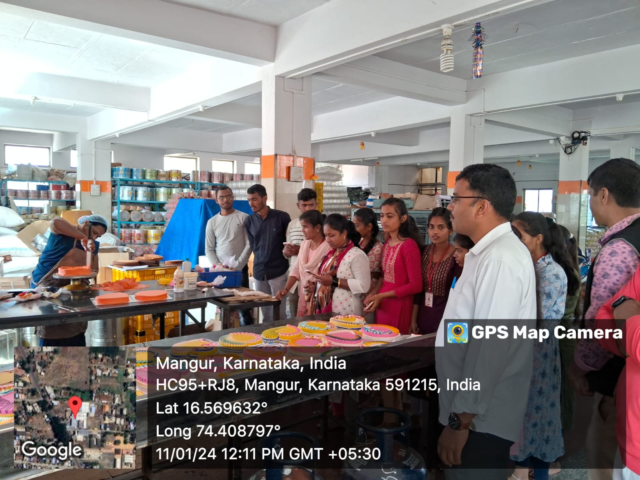

Dept. of Economics Visited Shri. Sai Cooperative Bakery Production Institution Mangur, Tal-Chikkodi, Dist- Belgum (Karnataka) on 9th January, 2024.

Head, Dept. of Economics Principal