Rayat Shikshan Sanstha’s

**Chandrabai-Shantappa Shendure College, Hupari**

**Activity Report**

**Name of the Activity :** Educational Tour

**Department** : Department of Economics

**Date** : 15th May, 2023

**Venue** : Khidrapur, Nrushihwadi

**Aims/Objectives** : 1. To acquire first-hand knowledge about a different side of living

especially economic and social aspects of rural areas.

2. To deepen social, economical and historical knowledge among

the students.

**Nature of the Activity:**

The Department of Economics organized study/education tour to Khidrapur and Nrushihwadi in Kolhapur District one of the historical and tourist places of the district on 15th May, 2023. For providing first-hand knowledge about rural areas and to deepen social, economical and social aspects the department of economics organized the educational tour. 35 students have participated in the activity. The activity has been conducted by Prof. Dr. J.S. Ingale, Dr. Barale S. I. Dr. Vijay Padlkar and Prof. M.L. Sontakke.

**Outcomes:**

1. Students have got social and economic knowledge of the rural areas.
2. Perspectives of the students have been enhanced by this activity.

**Support of teaching and non-teaching Staff**

1. Prof. Dr. J. S. Ingale
2. Smt. Shinde T.S.
3. Dr. Barale S.I.

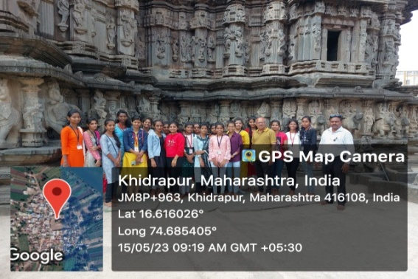

Head of the Department Principal