Rayat Shikshan Sanstha’s

**Chandrabai-Shantappa Shendure College, Hupari**

**Activity Report**

**Name of the Activity:** A Guest Lecturer on “Indian Stock Market”

**Department** : Department of Economics

**Date** : 26th December, 2023

**Venue** : Chandrabai Shatappa Shendure Collage Hupari

(Dist. Kolhapur)

**Aims/Objectives** : 1. Introduction to Indian Stock Market

2. To make proper planning of Investment.

.**Nature of the Activity:**

The Department of Economics and Commerce organized a Guest Lecturer on “Indian Stock Market’ on Tuesday, 26 December 2023. Mr. P.V. Gavali, Founder & CEO, Gavali Group of Business, Kolhapur was the Speaker. He guided on Indian stock market to the students. More than 100 Students of the Economics and Commerce department actively participated in the programme.

**Outcomes:**

1. Students understood working of Indian stock market.
2. How to make investment properly in financial market has been understood.

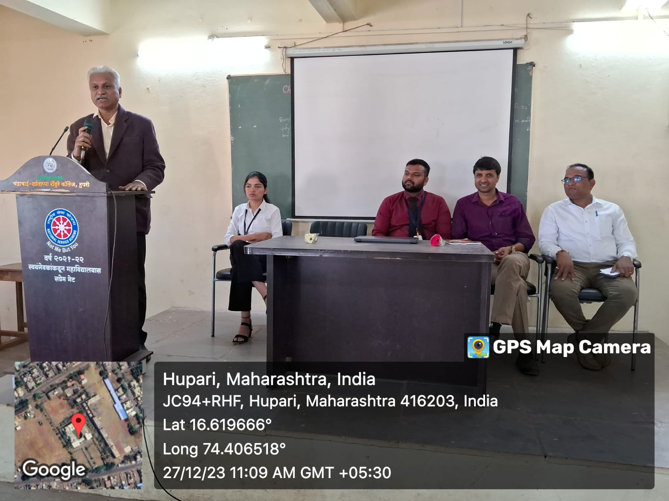

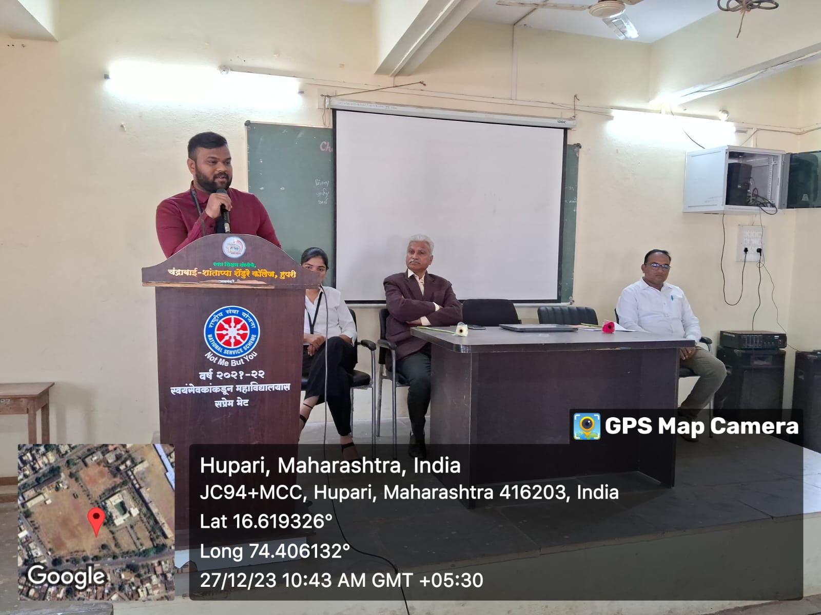

Head, Dept. of Economics Principal