**Rayat Shikshan Sansthas’**

**CHANDRABAI-SHANTAPPA SHENDURE COLLEGE, HUPARI**

**Activity Report**

**Name of the Activity :** Wallpaper- “Electronic Banking”

**Department** : Department of Economics

**Date** : 18th March, 2023

**Venue** : Chandrabai-Shantappa Shendure College, Hupari

**Aims/Objectives** : 1. To provide guidance and platform to the students with a

aptitude for creative thinking of Electronic Banking

2. To give wide publicity of publication of students

articles and creative arts in the wallpaper.

**Nature of the Activity:**

The Department of Economics organized study Wallpaper Presentation on “Electronic Banking” on 18th March, 2023. For providing platform and wide publicity of students’ creative thinking, Dept. of Economics organized wallpaper on above mentioned theme. This programme inaugurated by the auspicious hands of Prof. Dr. S. M. Bhosale and Dr. D. B. Shedage. 10 students have participated in the activity.The activity has been conducted by Prof. Dr. J.S. Ingale, Dr. Barale S. I. and Smt. Shinde.

**Outcomes:**

1. Students have got ideas and platform of wallpaper presentation.
2. Creative Presentation of Students have got wide publicity through the activity.

**Beneficiaries:**

10 Students of the Department

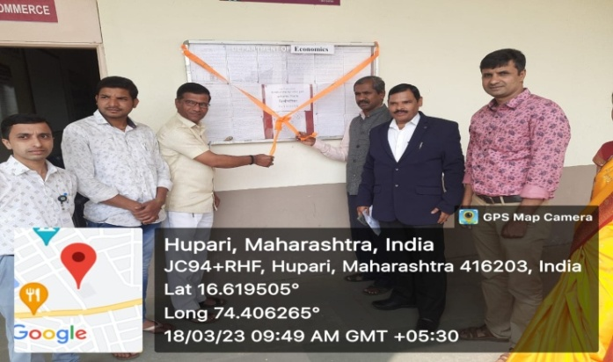

Head, Dept. of Economics Principal

Rayat Shikshan Sanstha’s

**Chandrabai-Shantappa Shendure College, Hupari**

Wallpaper Presentation- “Electronic Banking”

18th March, 2023

